Unity Bootcamp - Creating a 2D Game

Part 1 - Basic Functionality

# 

# Creating the project

Create a new Unity project. Select **2D** from the **Template** dropdown.

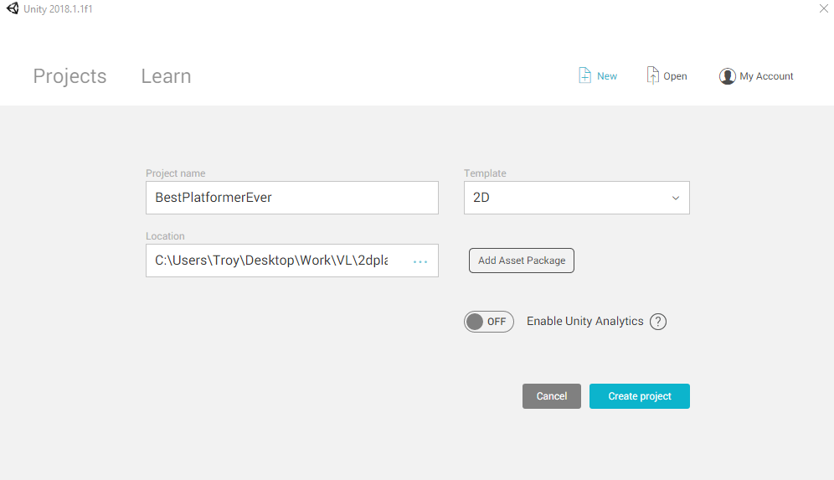

# Import the Package

Import the first package called ***Basic Package***by double clicking on it in your file browser, then pressing import. This package contains the 2D character, and some scripts we’ll be using.

# Import the Sprite Sheet

Create a Textures folder and import SpriteSheet.png. Click on the imported asset in Unity and look at the inspector (right side of the screen). Set *Sprite Mode* to ***Multiple*** and *Mesh Type* to ***Full Rect***. Then at the bottom of the inspector (you may have to scroll down) press *Apply*.

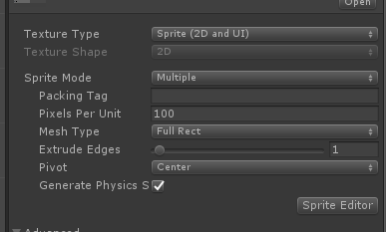

# Slicing the sprite sheet

Press the *Sprite Editor* button below where you just were changing things in the inspector to open the Sprite Editor.

Press *Slice* in the top left corner, make sure *Type* is ***Automatic*** and hit ***Slice****.* Then press ***Apply*** in the top right corner.

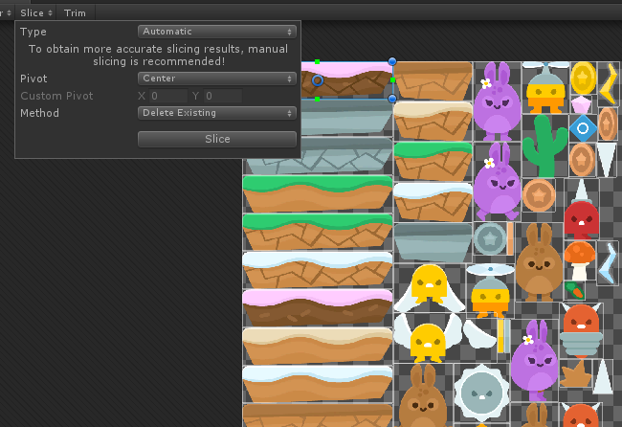

If you press the **little arrow** on the Sprite Sheet texture, it’ll expand to show all the possible sprites you can add to your game!

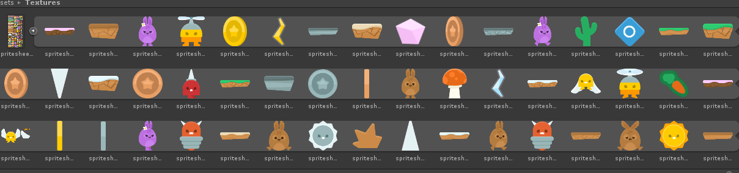

# Making ground for the player to jump on

Drag one of the ground looking sprites into the scene. Now in the inspector rename it to something like ‘Ground1’ and add a ***Box Collider 2D***component by pressing ***Add Component*** *and typing* ‘box’.

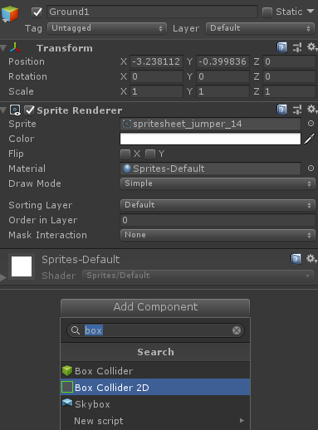

Now open the ***Prefabs*** folder in *Project Window* and drag *Ground1* from the hierarchy (left side) into the *Project Window* (next to the character prefab).

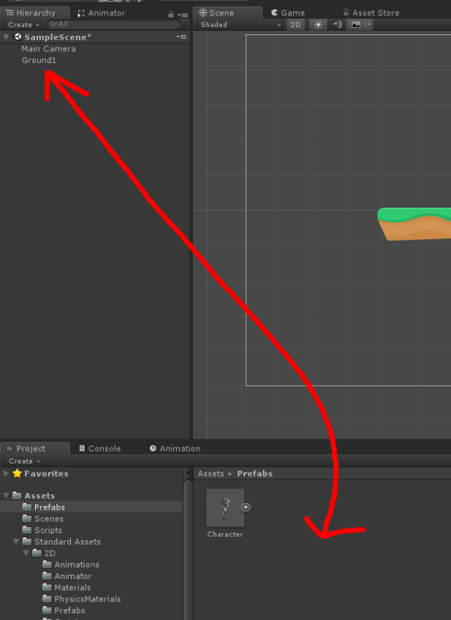

*Ground1* in the hierarchy will go blue and you will be able to drag *Ground1* from the *Project Window* into the scene. You’ll now be able to drag *Ground1* prefabs from the *Project Window* into the Scene and build a small level.

# Character

Drag the ***Character*** prefab from the *Prefabs* folder into the scene above some ground. Feel free to play around with the values in the ***Platformer Character 2D***component.

# Camera

Select the ***Main Camera*** *Game*Object in the hierarchy. Attach the ***Camera 2D Follow*** component to it by dragging the script from the *Project Window* (Assets > Scripts) or by pressing *Add Component* and searching for it. Once it has been added, set the ***Target*** as the ***Character*** and feel free to play around with the other values.

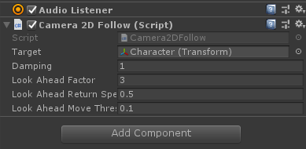

*Optional:* Change the *Background* colour in the *Camera* component to something other than that disgusting blue colour.

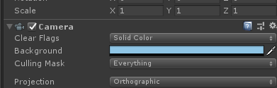

# Play Test

You can now press ***Play*** and if everything's working you’ll be able to jump around the scene and the camera will follow.

# Scene

Before we continue, we’re going to save the scene (File > Save Scene as...), call it *Level1*.

Now you need to add your new scene to the **build settings**, go to *File > Build Settings*. Now *Level1* should be the only scene in the build (delete *Sample Scene* if it’s there).

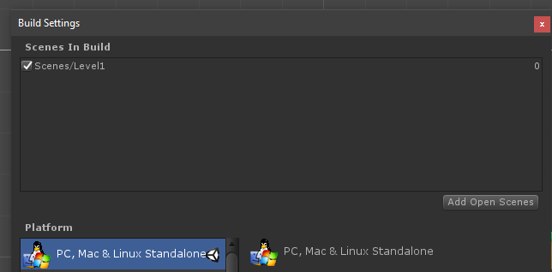

Sprite Credits: <https://www.kenney.nl/assets/jumper-pack>